We are seeking students in **Grade 4-6** to take on the role of Lunch Helper in our Kindergarten to Grade 3

Lunch Helpers Needed

classrooms.

The requirements for this position are listed below. The Learning Skills and Work Habits you will have the opportunity to build and demonstrate are shown in brackets followed by other words in *italics* that can be used to describe the same work habit.

For example, a coach or volunteer supervisor may have said you are *“Reliable”* and have good *“Teamwork”* skills. This is like saying you are “Responsible” and a good “Collaborator”. Knowing different words used to describe work habits can help you relate your school experiences to your experiences outside the classroom.

As a Lunch Helper, you will also have an opportunity to build your Essential Skills. These skills are used in work,

learning and life. Essential Skills are shown in **bold** after the work habits.

• Arrive on time to your assigned classroom (at the very beginning of the nutrition break). (Responsibility,

*Reliability*, **Scheduling or Budgeting and Accounting**)

• Read the rules posted in the classroom. (Responsibility, *Reliability,* **Reading Text**)

• Sit in your designated spot except when assisting students. (Responsibility, *Reliability*)

• Look for ways to assist students in the classroom. For example, help them to open containers when asked.

(Initiative)

• Work collaboratively with the students to remind them of the rules and expectations and to engage in play activities after they have finished their lunch. (Collaboration, *Teamwork*, **Oral Communication**)

• Be a good problem solver. For example, a student is not following the rules and is causing problems in the class. Gently remind the student of the rules and get the supervising staff member if the problem continues. (Initiative, Responsibility, *Self-advocacy*, **Oral Communication, Problem Solving**)

• Assist students in cleaning up their lunches and in getting ready to go outside. (Organization, Initiative)

• Ensure that all students have left the room, turn out the lights and close the classroom door. (Responsibility,

*Reliability*)

• Be a role model for all students in the class. (Self-Regulation, Responsibility, Initiative, *Reliability*)

• Find a replacement Lunch Helper should you be unable to complete one of your shifts. (Responsibility, *Reliability*)

• Schedule time to complete your tasks while taking into account your responsibilities in your other classes or extracurricular activities. (Organization, **Scheduling or Budgeting and Accounting**)

You can **transfer** your Essential Skills and work habits to everyday life or the next place you go – whether it’s further education, training or the workplace. More information on how you use your Essential Skills and work habits in everyday life is on the Ontario Skills Passport website.

Lunch Helper - page 2

Identifying and reflecting on the Essential Skills and work habits you demonstrate as a Lunch Helper will help you develop your “All About Me” portfolio as you answer the four education and career/life planning inquiry questions: ***Who am I? What are my opportunities? Who do I want to become? What is my plan for achieving my goals?***

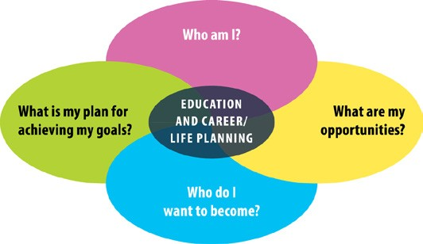

ontario.ca/skillspassport